

**Comprehensive Financial Data Visualization Analysis**

Based on your interest in charts, figures, and graphs, I've created a comprehensive suite of visualizations analyzing the financial data from your dataset. Here's what the analysis reveals:

**Key Visualizations Created:**

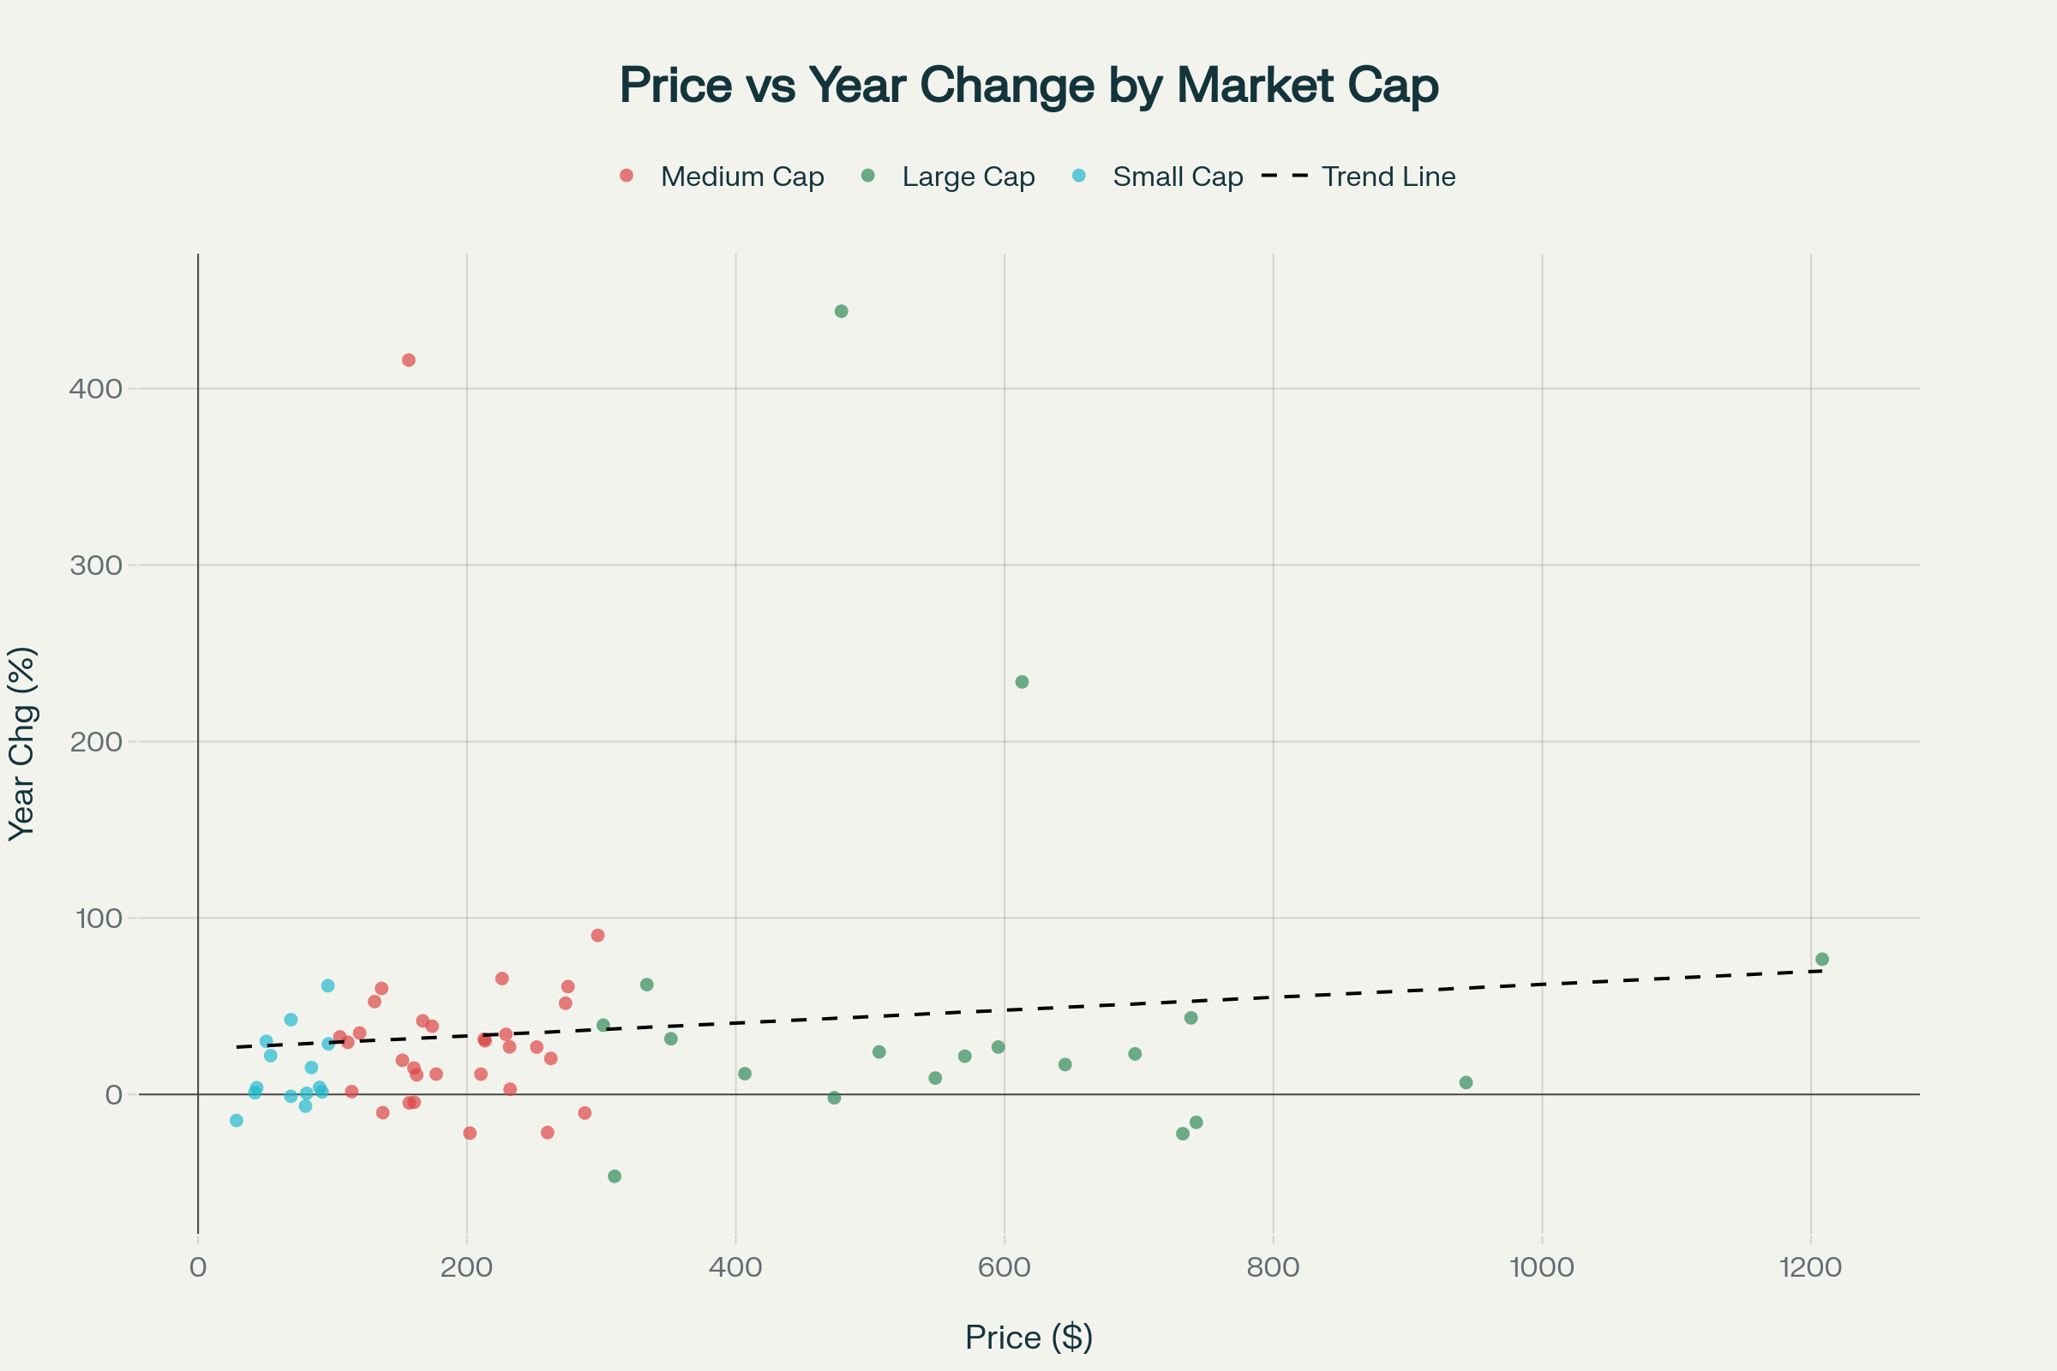

Stock Price vs Annual Performance: Relationship between current stock price and yearly percentage returns across major stocks

**Stock Price vs Annual Performance Scatter Plot**: Shows the relationship between current stock prices and yearly returns across 64 major stocks, revealing that higher-priced stocks don't necessarily deliver better returns.

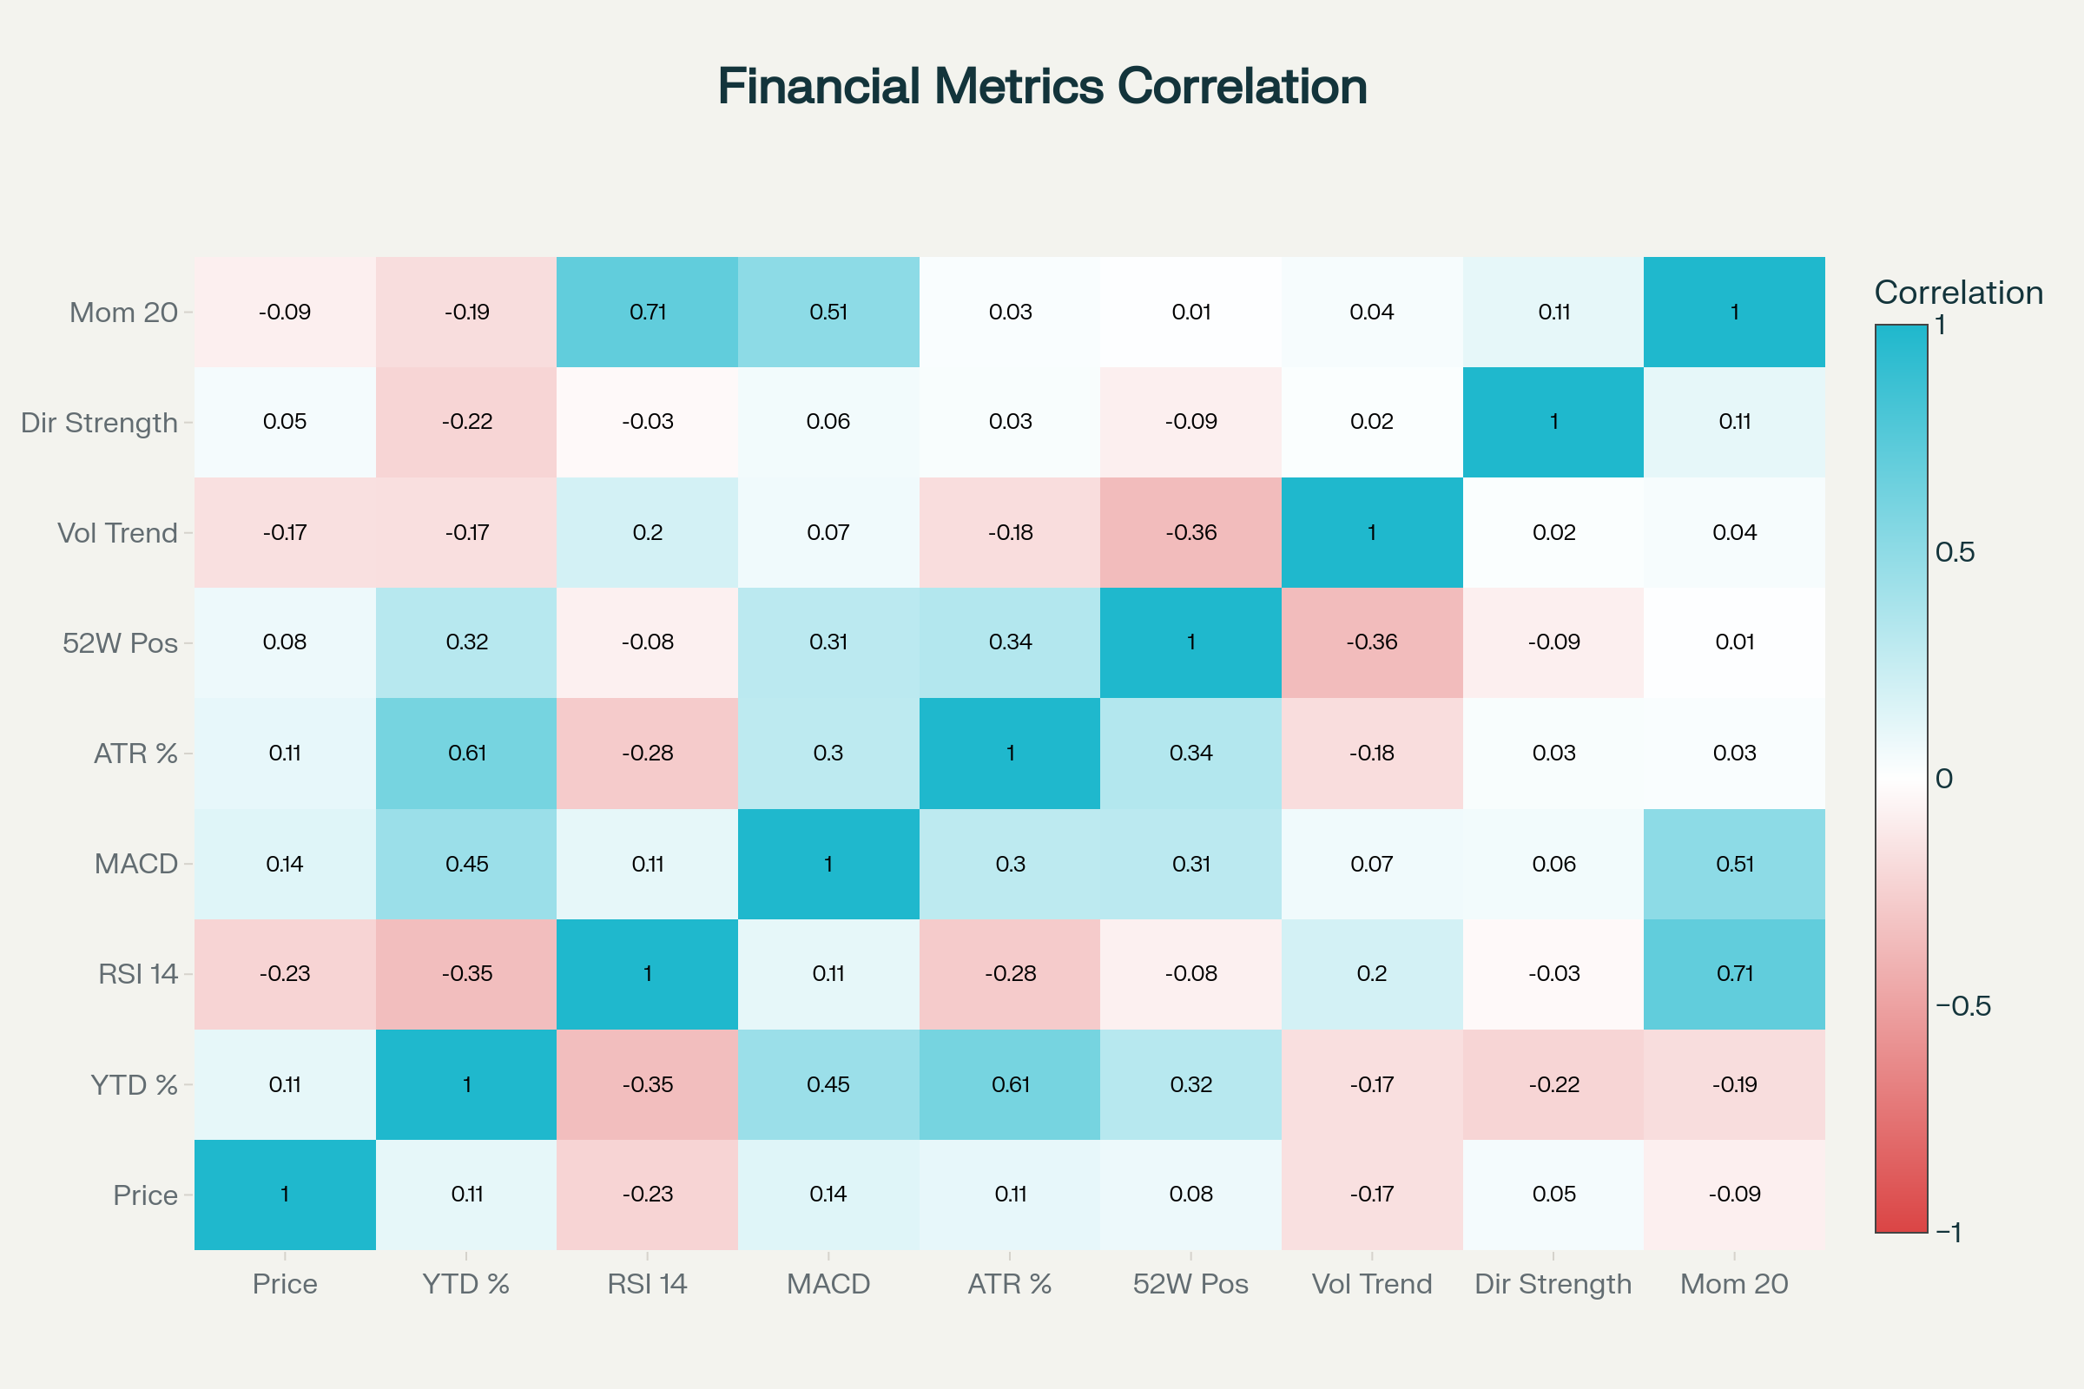

Financial Metrics Correlation Matrix: Heatmap showing relationships between key stock performance indicators and technical analysis metrics

**Financial Metrics Correlation Heatmap**: Displays correlations between 9 key financial indicators including price, returns, RSI, MACD, volatility, and momentum. Notable findings include strong correlations between certain technical indicators.

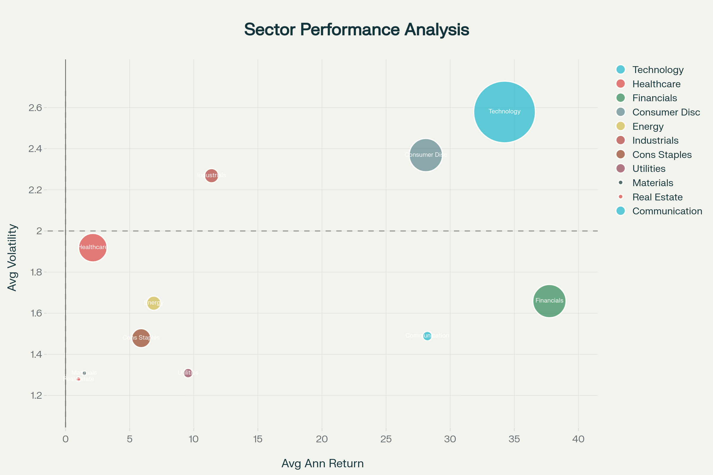

Sector Performance vs Risk Analysis: Bubble chart showing annual returns, volatility, and market representation across major market sectors

**Sector Performance Bubble Chart**: Analyzes performance across 11 market sectors, with bubble sizes representing the number of stocks analyzed. **Financials** lead with 37.74% average returns, followed by **Technology** at 34.24%.

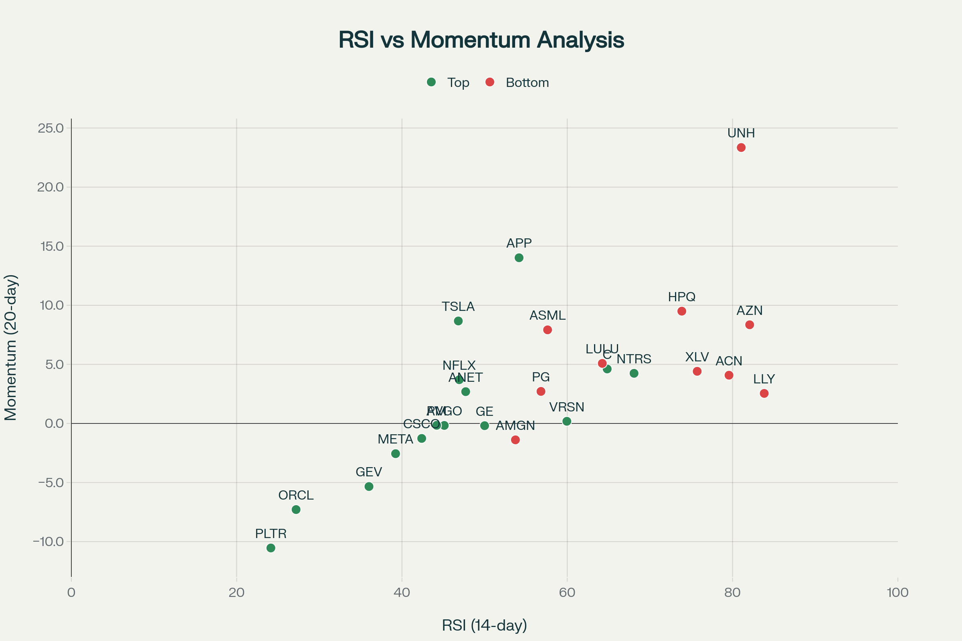

Top vs Bottom Stock Performers: Analysis of annual returns and technical indicators for extreme performers in the market

**Top vs Bottom Performers Analysis**: Two-panel chart showing extreme performers. **APP** (+443.85%) and **PLTR** (+416.17%) lead winners, while **UNH** (-46.36%) and **LLY** (-22.21%) are notable underperformers.

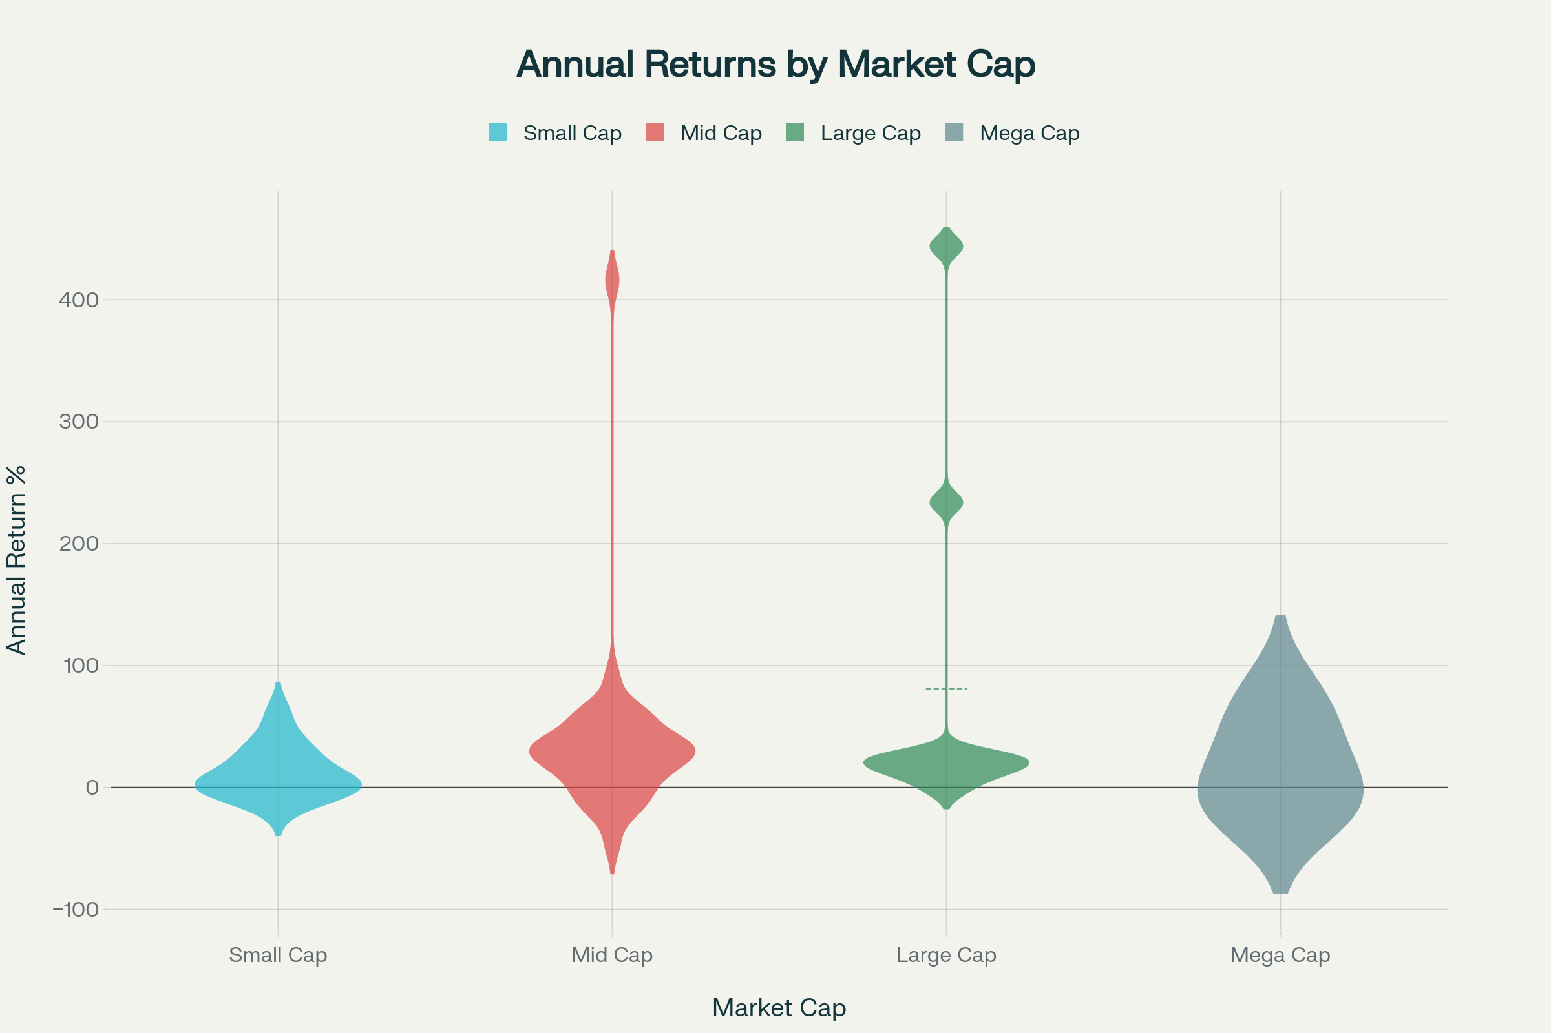

Annual Returns Distribution by Market Cap: Violin plot showing return distributions across different market capitalization categories

**Market Cap Returns Distribution**: Violin plot showing how returns vary by market capitalization categories. **Large Cap** stocks show the highest average returns (56.60%) but with significant volatility.

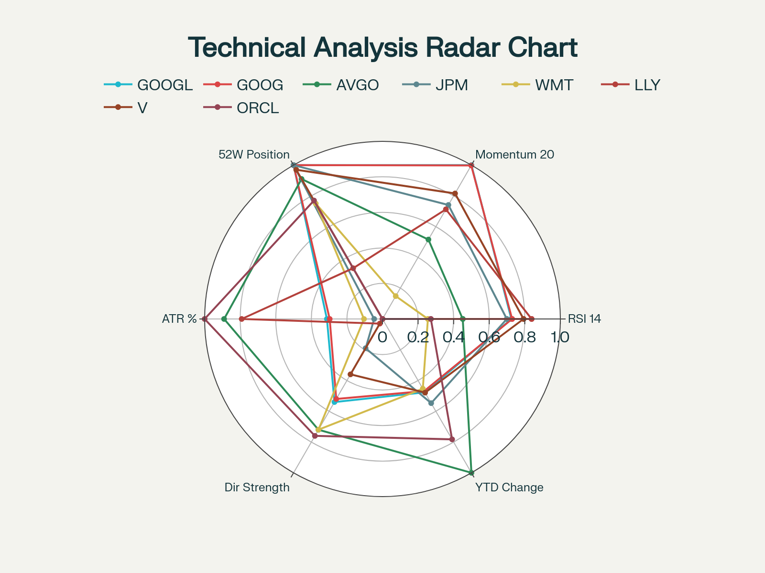

Technical Analysis Radar Chart: Multi-dimensional technical indicator comparison for stocks with notable patterns

**Technical Analysis Radar Chart**: Multi-dimensional comparison of 6 technical indicators across 8 stocks with notable patterns, providing a comprehensive view of each stock's technical profile.

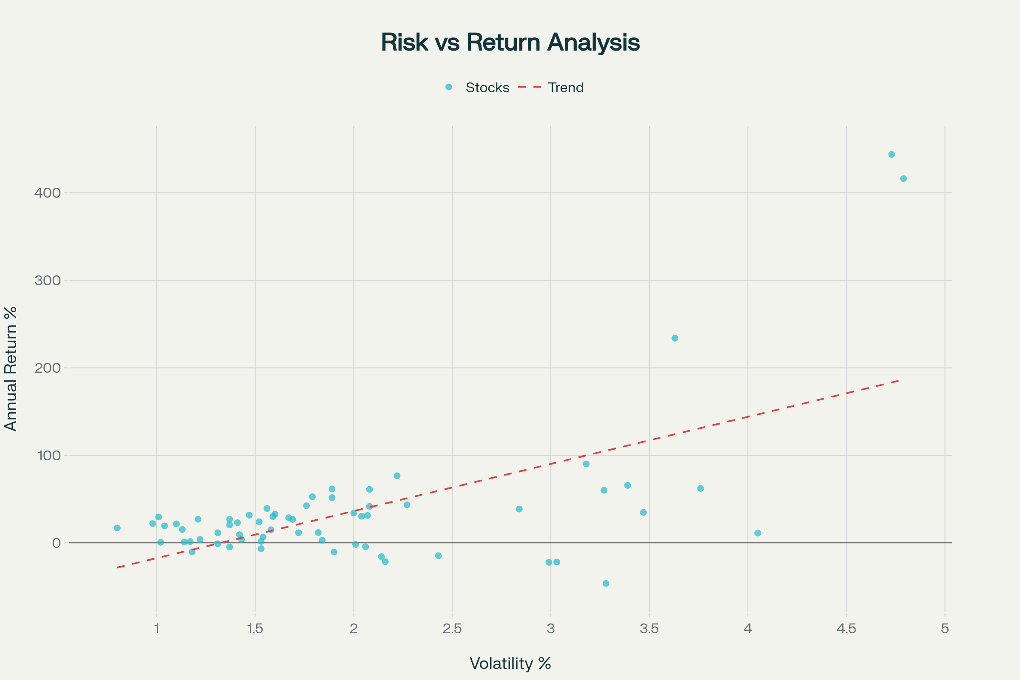

Comprehensive Stock Market Dashboard: Multi-panel analysis showing top performer trends, RSI distribution, risk-return relationship, and sector performance

**Comprehensive Market Dashboard**: Four-panel dashboard combining top performer trends, RSI distribution analysis, risk-return relationships, and sector performance comparisons.

**Key Insights from the Visualizations:**

1. **Performance Leaders**: APP, PLTR, and GEV are standout performers with returns exceeding 200%
2. **Sector Analysis**: Financials and Technology sectors dominate performance
3. **Technical Patterns**: 18 stocks are currently in overbought territory (RSI > 70)
4. **Risk-Return Profile**: Higher volatility doesn't always correlate with higher returns
5. **Market Cap Effects**: Large cap stocks show the most diverse return patterns

These visualizations provide a comprehensive view of market dynamics, technical indicators, and performance patterns across your dataset. Each chart offers unique insights into different aspects of the financial markets represented in your data.

⁂

1. basic_calculation_daily_0_20250829.csv

1. tradingview_universe.csv